ERD Diagram of XReplica: Social Media App

GROUP MEMBERS: MUHAMMAD ABU BAKAR, ASADULLAH KHAN

SUBMIT TO: SIR SHAKIR RASHEED

SUBJECT: Introduction to Database

NAME | GitHub Link
MUHAMMAD ABU BAKAR | Repository Link
ASADULLAH KHAN | Repository Link

Introduction
This project presents the ERD of a social media app inspired by X. The diagram covers the main entities of the platform, including users, tweets, comments, likes, subscriptions, and followers, and shows how they interact. It provides a clear structure for managing data and serves as the foundation for building an efficient and scalable social media database.
Full ERD Diagram
Below is the complete conceptual ERD diagram for the project:
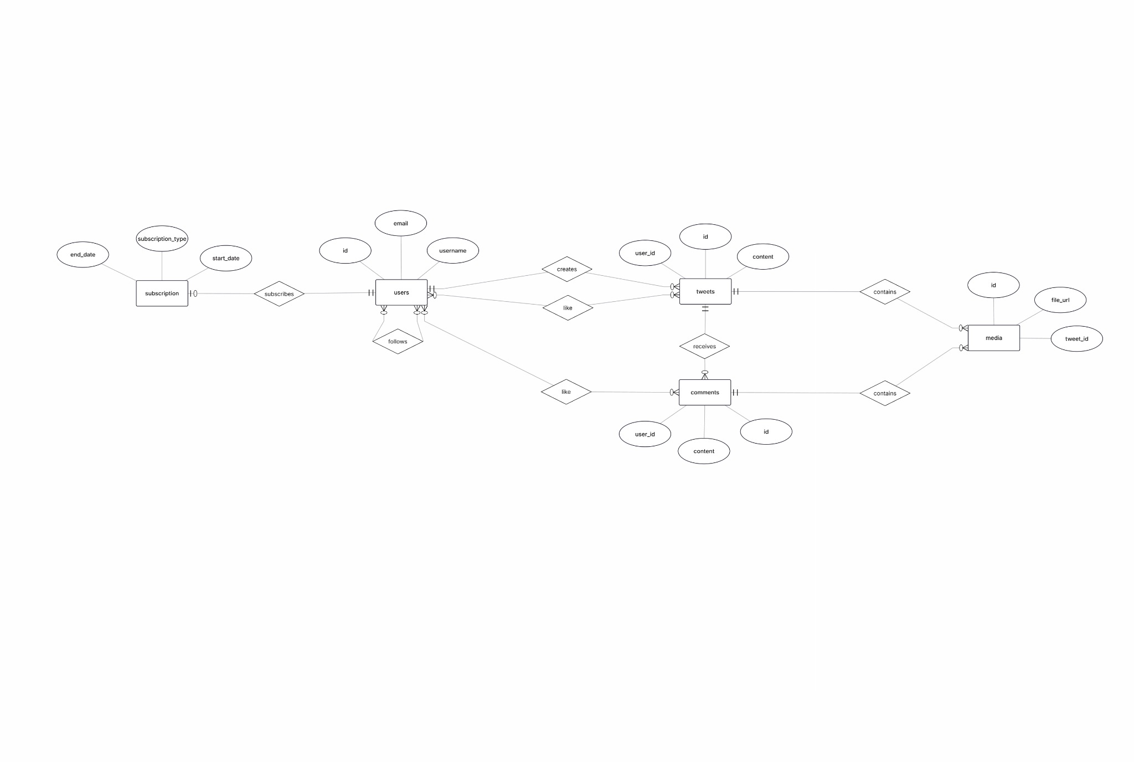

ERD Breakdown & Explanations
Users Entity
The users entity represents all registered members of the platform. Each user has attributes such as ID, username, and email. Users engage with the system by creating tweets, posting comments, following other users, and liking content.
Tweets Entity
The tweets entity holds user-generated posts. Each tweet includes a unique ID, a user ID linking it to its creator, and its content. Tweets can receive comments, likes, and media attachments.
Comments Entity
The comments entity stores reactions left by users on tweets. Each comment is associated with both a user and a tweet. Comments themselves can be liked as well.
Likes Relationships
Likes are represented as two separate relationships:
- Users like tweets
- Users like comments
These relationships show user engagement with content across the platform.
Media Attachments
The media entity stores information about files attached to tweets, such as images or videos. Each media item contains a file URL and is linked to a specific tweet.
Subscriptions
The subscription entity keeps track of premium user memberships. Each subscription entry includes a start date, end date, and subscription type, and it is linked to a specific user.
Follow System
The follows relationship handles user-to-user connections, allowing one user to follow another. This relationship models the social networking aspect of the platform.

Assumptions & Constraints
- A user must exist before creating tweets or comments.
- Subscriptions are optional and only apply to users who opt in.
- Likes are only counted once per user per tweet/comment.
- Follow relationships cannot link a user to themselves.

